TERAFORM NOTES-

Used to create or provision infrastructure in Cloud Platform.
It is Infrastructure as a code(iaac)
Free and open source
Supports every cloud platforms
Uses HCL Language(Hashicorp Configuration Language)

Why it is Called Infrastructure as a Code?
It means writing a code in order to Provide the infrastructure .

From outside if u want to provision any of the infrastructure on your cloud then u required to create the access key . And after creating the access key on aws platform u have to go to environment variables and add new variable as Access_Key and another variable as Secret_Access_Key paste it there.

Other Way using Linux commands -
Open the pem terraform file right click on pem file and open gitbash and paste the ssh from the ec2 launch instance connection .Everytime u have to set the environmental variables when u are working means everytime u have to provide the credentials like access key and secret access key .Otherwise u are not able to run the terraform scripts .

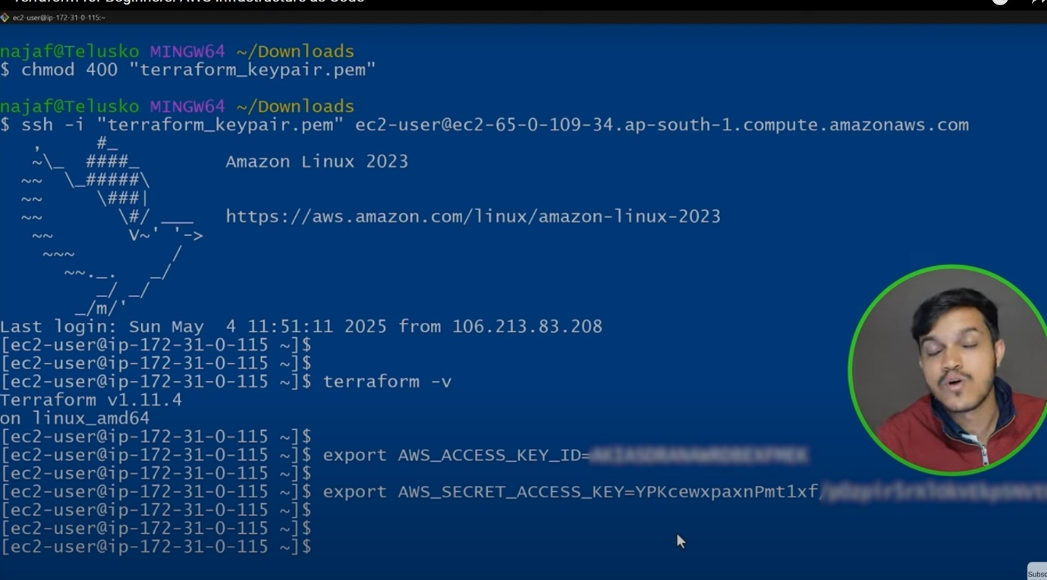

For the terraform script file in HCL we save it as with .tf extensions.

In order to initialize the terraform script we write terraform init.
In order to format your terraform commands we use terraform fmt command .Its an optional step and manages the formatting basically .
Another imp command is terraform validate is used to validate the terraform syntax whether everything is fine or not.
Terraform apply will execute your terraform script. Responsible for creating resources on the cloud .
Terraform destroy used to destroy the terraform scripts using this can destroy all the resources created.

What is the difference between plugin and provider ?
A configuration block in Terraform that specifies which cloud/service Terraform should interact with and how to authenticate.
The binary executable that actually implements the functionality of the provider, communicates with the API, and manages resources.

What are the other alternatives for terraform ?
The other alternatives for terraform are ansible and puppet/Chef.

MOCK INTERVIEW QUESTIONS ON TERRAFORM

Q1. What is Terraform?
A: Terraform is an open-source Infrastructure as Code (IaC) tool that allows you to provision, manage, and version cloud and on-prem resources using declarative configuration files.

Q2. What are the key features of Terraform?
A:
- Infrastructure as Code (IaC)
- Platform-independent (supports AWS, Azure, GCP, etc.) Open source in nature
- Dependency graphing (automatic ordering of resource creation)
- Execution plans (terraform plan)
- State management (terraform state)
- Modular & reusable code (modules)

Q3. Difference between terraform apply and terraform plan
A:
- plan: Shows the execution plan without applying changes.
- apply: Applies the changes to create/update/delete resources.Final step of creating terraform scripts in TCl.

Q4. What is a Terraform provider?
A: A provider is a plugin that allows Terraform to interact with APIs of cloud platforms (e.g., AWS, Azure, GCP) or services.

Q5. What is Terraform state?
A: Terraform keeps track of resources in a state file (terraform.tfstate) which maps configuration files to real infrastructure.
- Can be local or remote (S3, Azure Blob, GCS)
- Used for drift detection and dependency management

Q6. What are Terraform modules?
A: Modules are reusable Terraform code blocks for a specific purpose (e.g., VPC module, EC2 module).
- Can be local, registry-based, or remote Git-based.

Q7. What is a workspace in Terraform?
A: Workspaces allow multiple state files for the same configuration, useful for dev, staging, prod environments.

Q8. What are Terraform variables?
A: Variables allow dynamic configuration. Types:
- string, number, bool, list, map
- Declared in .tf or .tfvars files
- Can be passed via CLI, env variables, or default values

Q9. How do you pass sensitive data in Terraform?
A: Use sensitive = true in variable declaration. For secrets, use Vault, AWS Secrets Manager, or Azure Key Vault.

2️⃣ Intermediate
Q10. What are provisioners in Terraform?
A: Provisioners execute scripts on resources after creation.
- Types: local-exec (runs locally), remote-exec (runs on remote machine)
- Example: Installing software on EC2 after creation

Q11. What is the difference between terraform import and terraform apply?
A:
- import: Brings existing resources into Terraform state
- apply: Creates or updates resources as per the configuration

Q12. How do you handle Terraform state in team environments?
A: Use remote state backend with state locking:
- AWS S3 + DynamoDB
- Azure Blob + Storage Locking
- Terraform Cloud / Enterprise

Q13. What are lifecycle rules in Terraform?
A: Lifecycle rules define resource behavior:
- create_before_destroy → Create new before deleting old
- prevent_destroy → Prevent accidental deletion
- ignore_changes → Ignore changes to certain attributes

Q14. What is Terraform import vs data source?
A:
- import: Adds existing resource to state
- data: Reads information from existing resource without managing it

Q15. What is Terraform plan output?
A:
- + → Add resource
- ~ → Modify resource
- - → Delete resource

Q16. How to rollback Terraform changes?
A: Use terraform destroy to remove resources or apply previous saved state from remote state backend.

3️⃣ Advanced / Scenario-Based
Q17. How do you manage multiple environments in Terraform?
A:
- Use workspaces (terraform workspace new dev)
- Or use separate directories with backend configurations
- Or use modules + variable files (dev.tfvars, prod.tfvars)

Q18. What is a remote backend? Name examples.
A: Remote backend stores Terraform state in a shared location.
Examples:
- AWS S3 + DynamoDB
- Azure Blob Storage
- Google Cloud Storage
- Terraform Cloud / Enterprise

Q19. What is Terraform drift? How do you detect it?
A: Drift occurs when actual infrastructure differs from Terraform state.
- Detect using terraform plan or terraform refresh

Q20. How do you resolve dependency errors in Terraform?
A:
- Terraform creates a dependency graph automatically
- Use depends_on explicitly if required
- Ensure resources referenced by outputs/variables exist before usage

Q21. How do you secure secrets in Terraform?
A:
- Avoid hardcoding in .tf files
- Use Vault, AWS Secrets Manager, Azure Key Vault
- Mark variables as sensitive = true
- Use environment variables or .tfvars files ignored in Git

Q22. How do you handle Terraform version upgrades?
A:
- Use terraform 1.x required_version block
- Upgrade Terraform CLI in isolated environment
- Run terraform init -upgrade and terraform plan to check for compatibility

Q23. How do you import existing cloud infrastructure into Terraform?
A:
- Use terraform import <resource_type>.<name> <id>
- Then run terraform plan to sync configuration with imported state

Q24. What is a Terraform data source?
A:
- Reads info about existing resources without managing them
- Example: data "aws_vpc" "default" { filter { name = "default" } }

Q25. How do you implement modules in Terraform?
A:
module "vpc" {
source = "./modules/vpc"
vpc_name = "my-vpc"
cidr_block = "10.0.0.0/16"
}
- Modules make code reusable, consistent, and easier to maintain.

Q26. How do you debug Terraform errors?
A:
- Use TF_LOG=DEBUG terraform apply for detailed logs
- Check terraform state list to see managed resources
- Validate syntax: terraform validate
- Check plan differences: terraform plan -out plan.tfplan

Q27. What are common Terraform interview scenarios?
Scenario | Approach
EC2 creation fails | Check AMI ID, subnet, security group
RDS cannot be created | Check subnet group, VPC, parameter group
Terraform says resource exists | Use terraform import or terraform taint
Multiple teams updating state | Use remote backend with locking
Secret leak in Git | Rotate secrets, use sensitive variables & Vault

Q28. Commands you must know
- terraform init → Initialize directory
- terraform plan → Preview changes
- terraform apply → Apply changes
- terraform destroy → Delete resources
- terraform fmt → Format files(Optional)
- terraform validate → Validate syntax
- terraform state list → List resources in state
- terraform import → Import existing resource
- terraform taint → Mark resource for recreation

